

**Ahsanullah University of Science and Technology (AUST)**

Department of Computer Science and Engineering

**RESORT ADMINISTRATION**

**Final Project Report**

Course No: CSE 2100

Course Title: Software Development Lab II

**Submitted To-**

**Tanveer Ahmed Belal, Assistant Professor**

**Ashna Nawar Ahmed, Lecturer**

**Submitted By-**

Group no. – 08

Section – A2

Tabia Morshed

20200204027

MD Musaddique Ali Erfan

20200204049

Year- 2nd

Semester-1st

Department-CSE

**Resort Administration**

**Introduction:**

“Resort Administration” is a resort management software for monitoring and controlling features of a resort. We developed our project in NetBeans 8.2 and MySQL. This software mainly focuses on the basic requirements of any resort as well as some key features like the facility of customer login and facility administrative login. New customers can easily open a user account after filling up a registration form provided with a username and password. Customers must log in or sign up in order to access all the features. After that, they can see the list of rooms, resorts, tours, etc in our resort. A customer will have the opportunity to get a gym pass, withdraw money from his bank account, book a destination for traveling, and request emergency medical assistance. By administrative login, admins can keep track of the whole resort system. Admins will have access to register customers, update details, and view customer profiles. There will be a review option for the customers to suggest anything about the resort to improve. Reviews later can be observed by the admins. Overall, the objective of this project is to provide a friendly environment to the customers. And also, the staff working at the resort maintain it in the best way possible and help reduce human efforts.

**Identification of functional requirements:**



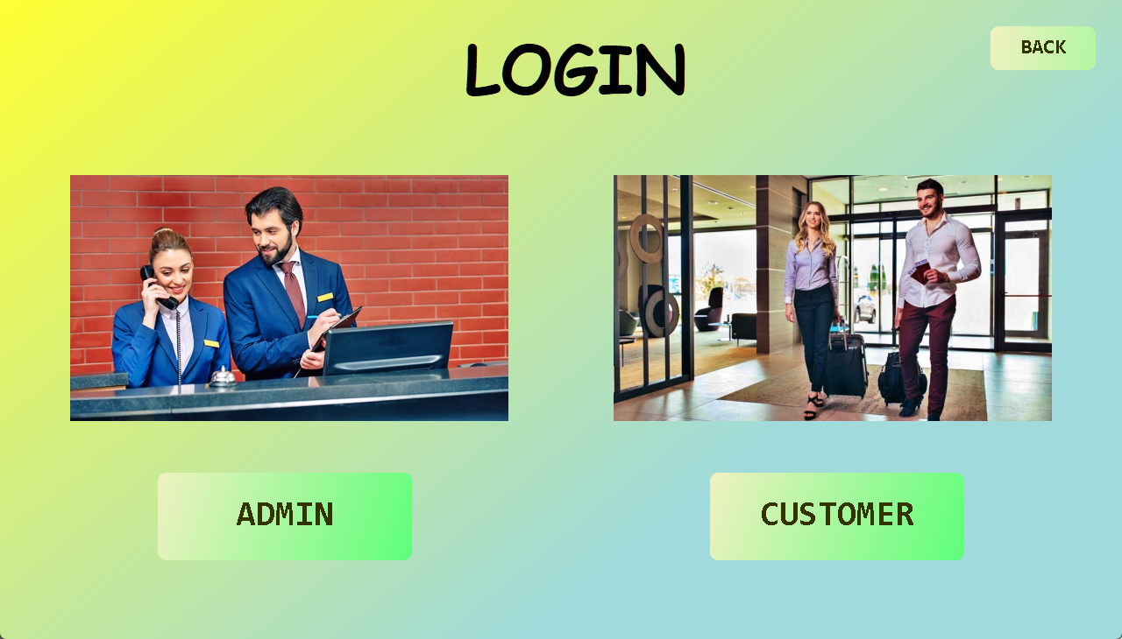

**• User Login:**

This feature will give users the ability to access the system. A Username and Password are needed to sign into the system. For signup, some information is necessary with a Username and Password. Only verified users can enter the system if those credentials match. If the Username or Password does not match, no one will be able to enter the system and asked to give the proper credentials. User login will allow a customer to access all the features the resort has to offer.

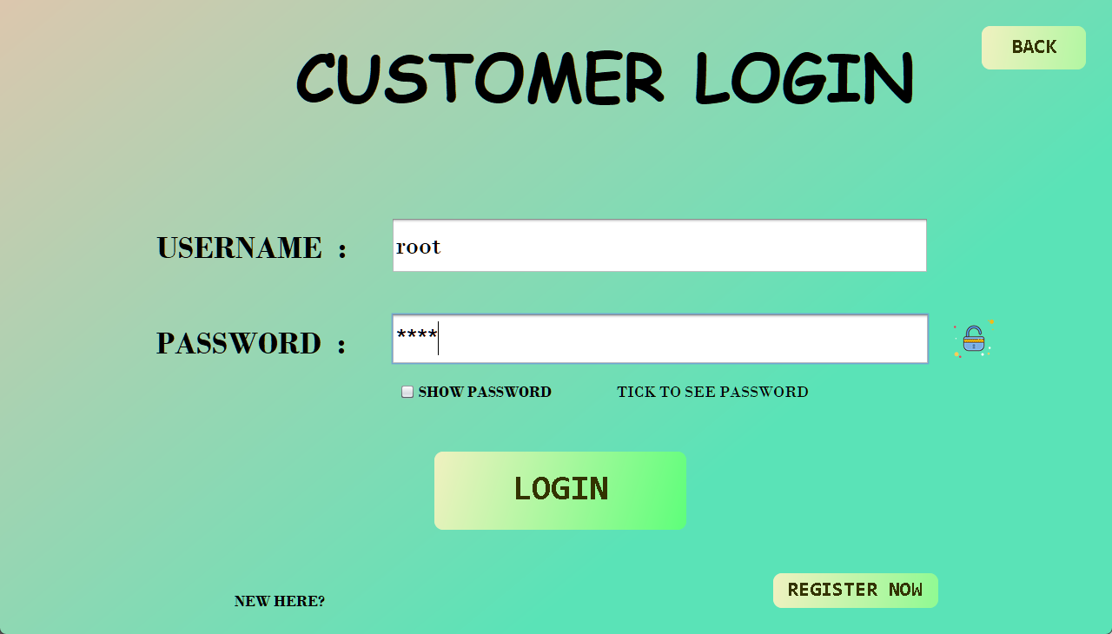

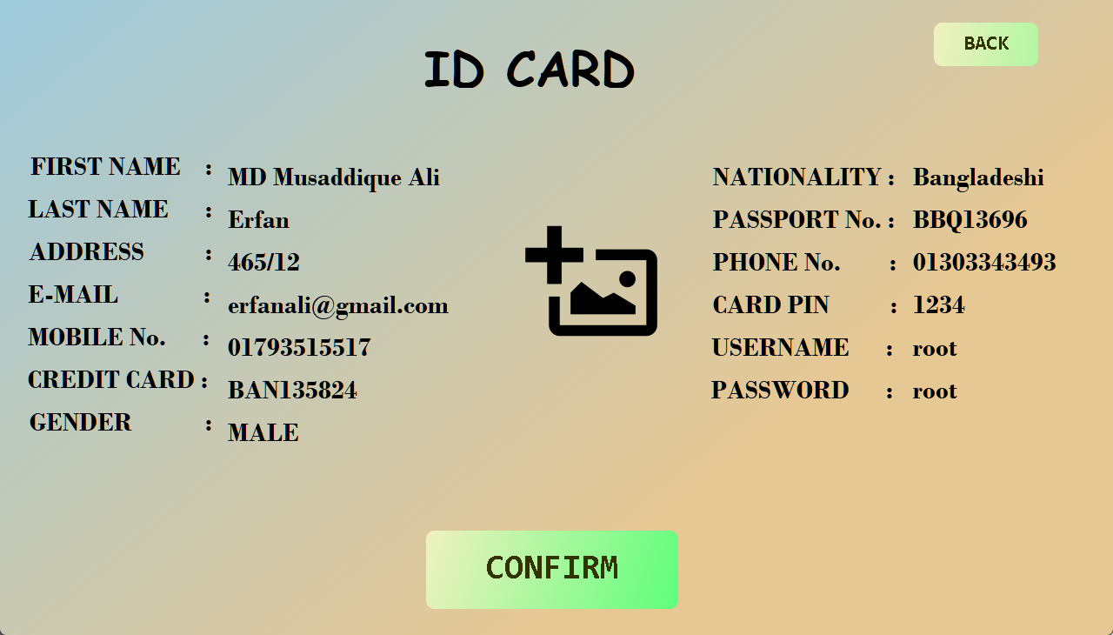

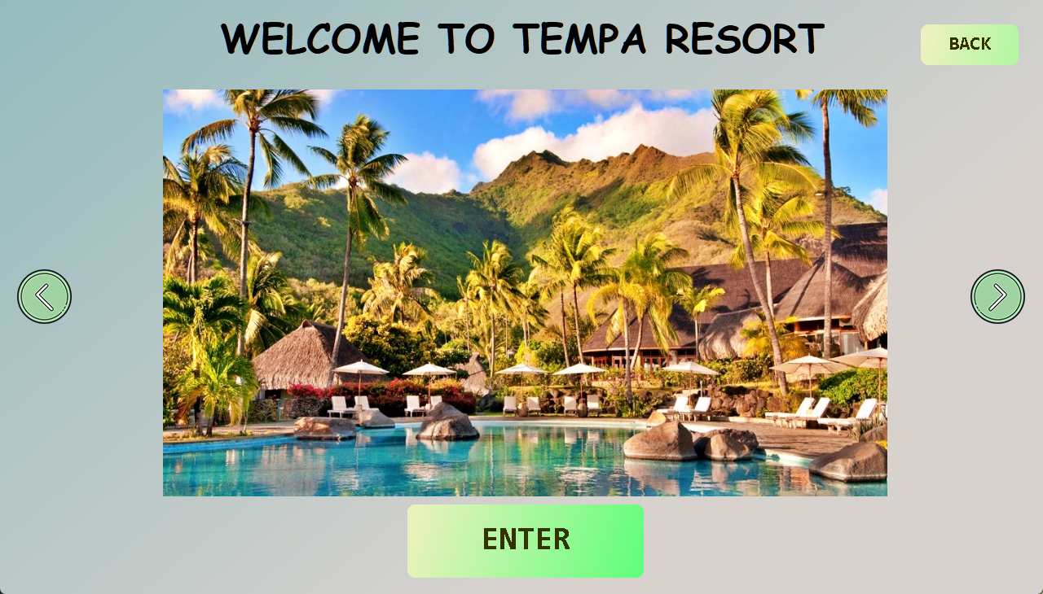

**• Administrative Login:**

This feature allows administrative personnel to log in to the system by providing a username and password. After the verification, the admin will be able to access the admin section of the resort. Username and password mismatch will restrict someone from entering the admin section. Through administrative login, an admin can access special features which are required to manage the resort.

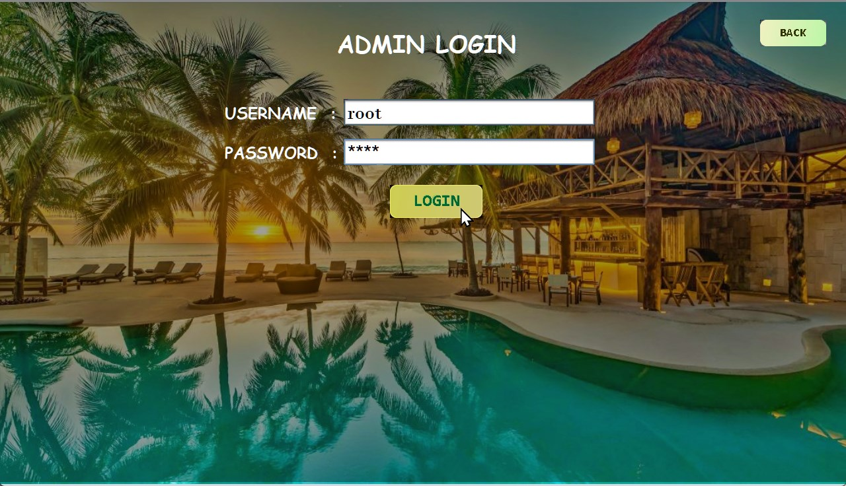

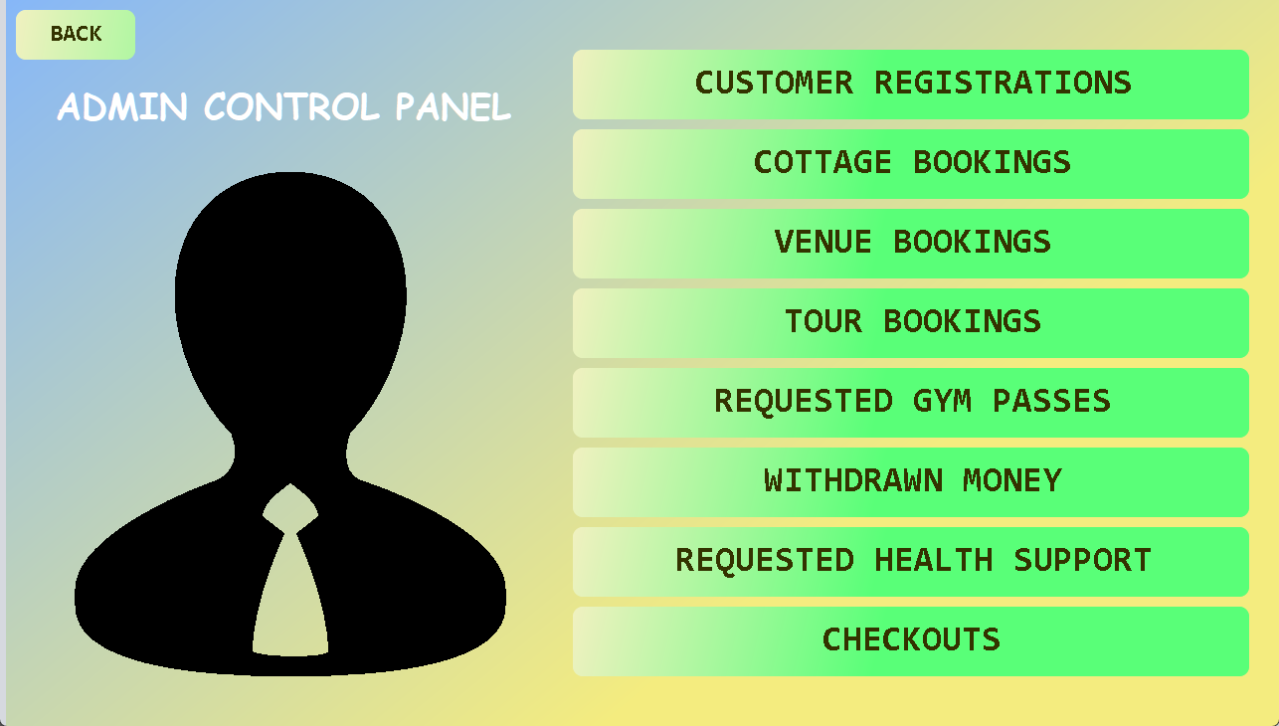

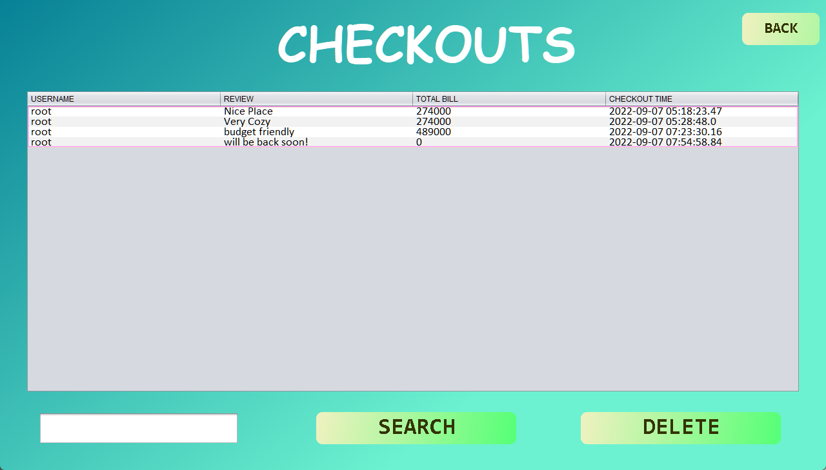

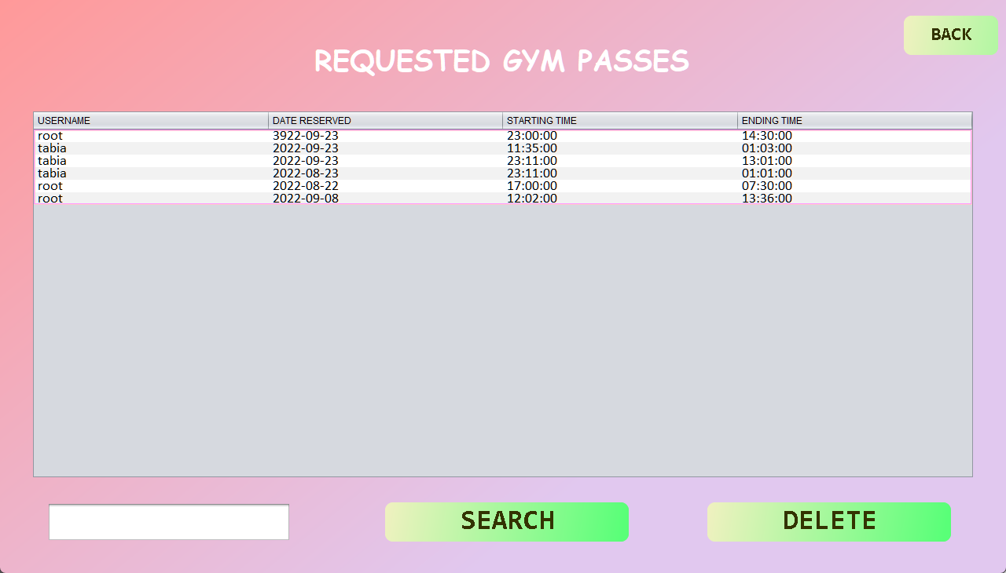

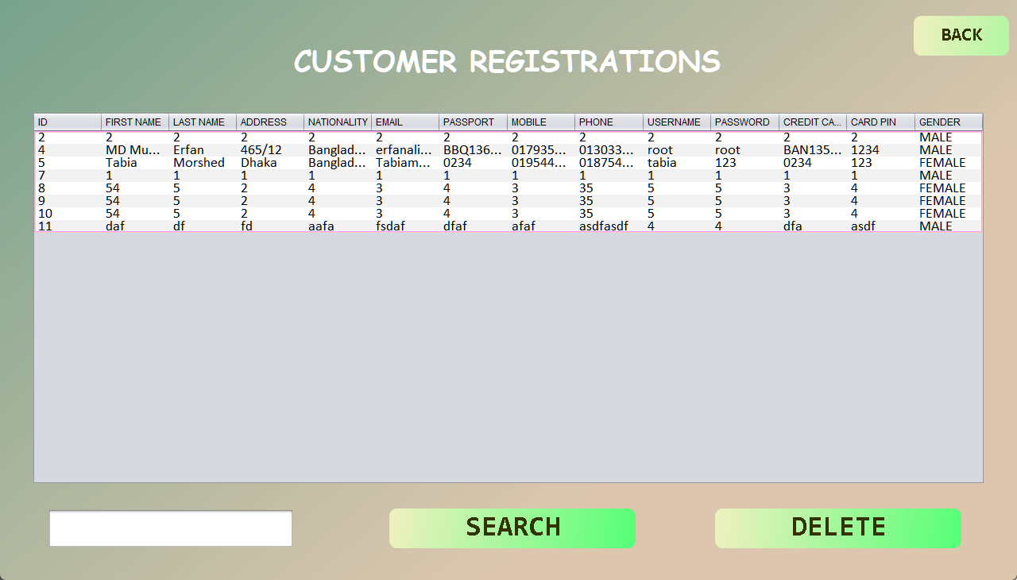

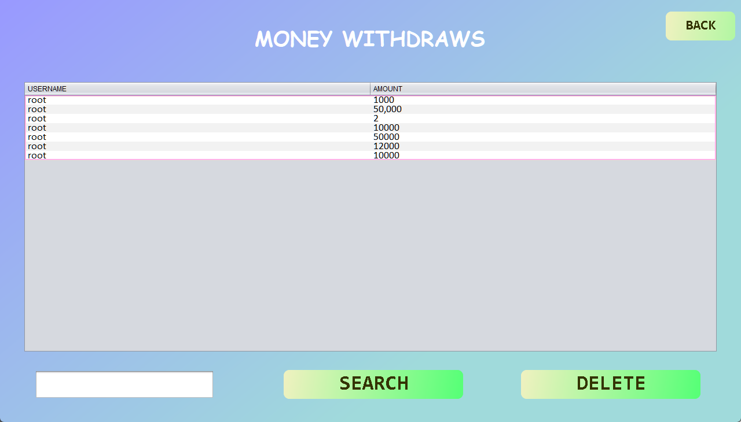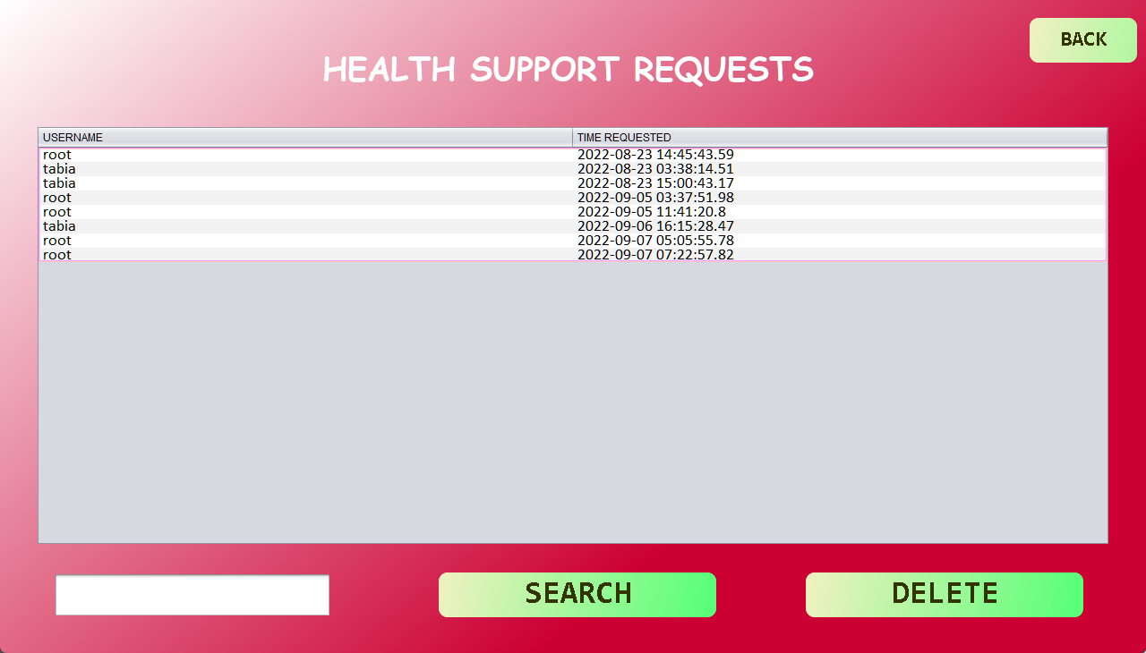

**• Customer Registration:**

This feature allows anyone to create an account for using the resort facilities. This option will be available at the very beginning of our program. New customers will have to fill out a registration form in order to create an account. After providing the required information, he/she will gain access to the system.

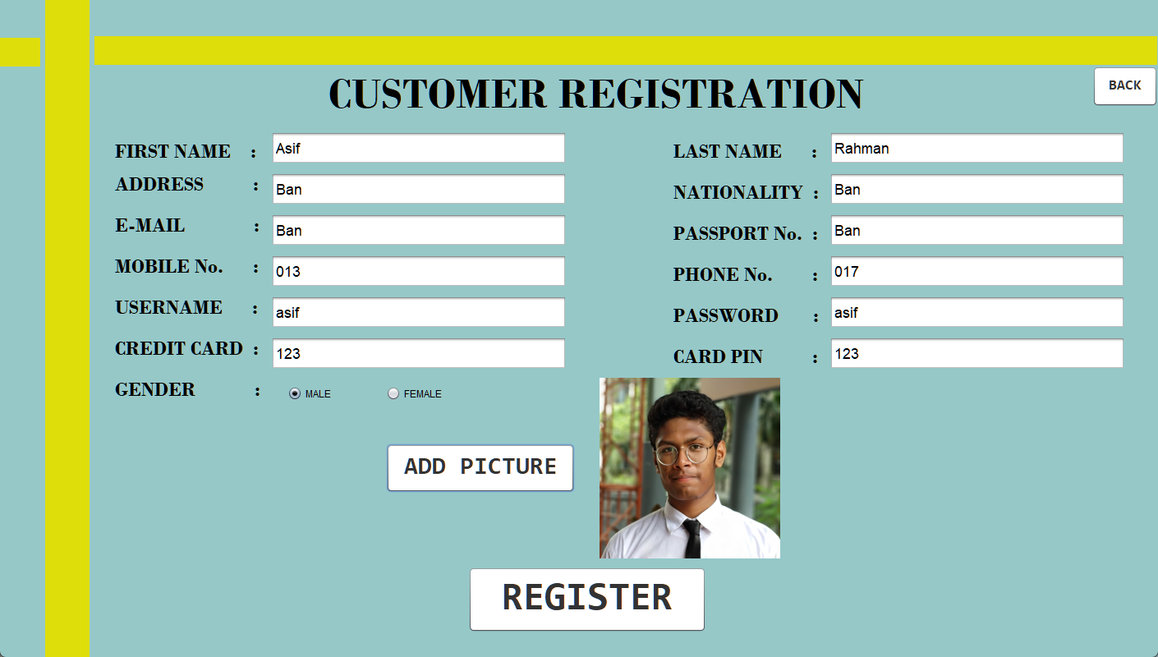

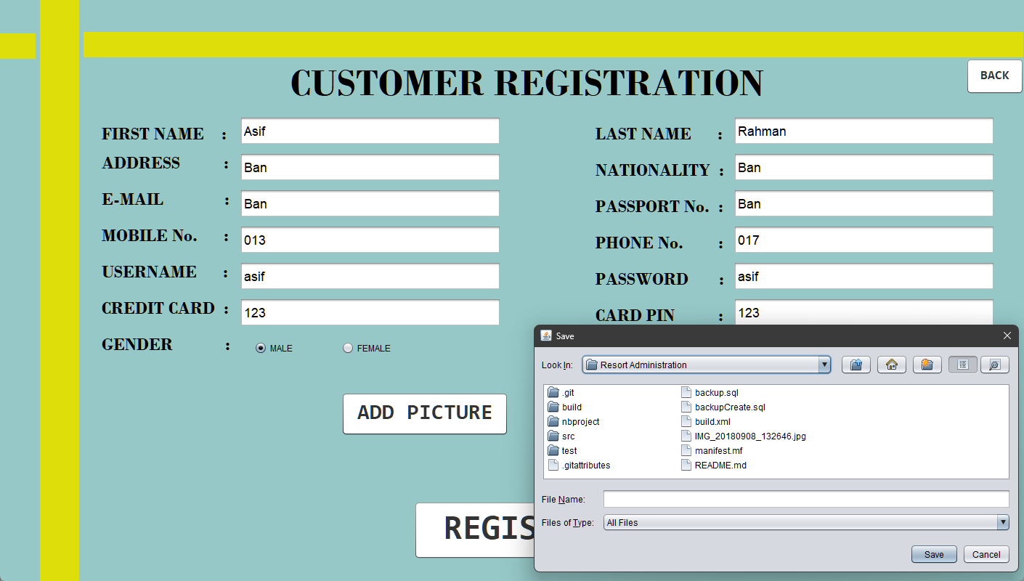

**• Book A Cottage:**

This feature allows customers to book available room(s) in the resort. They will be able to see how the room looks and the features that come along with the room. There will be different categories for selection.

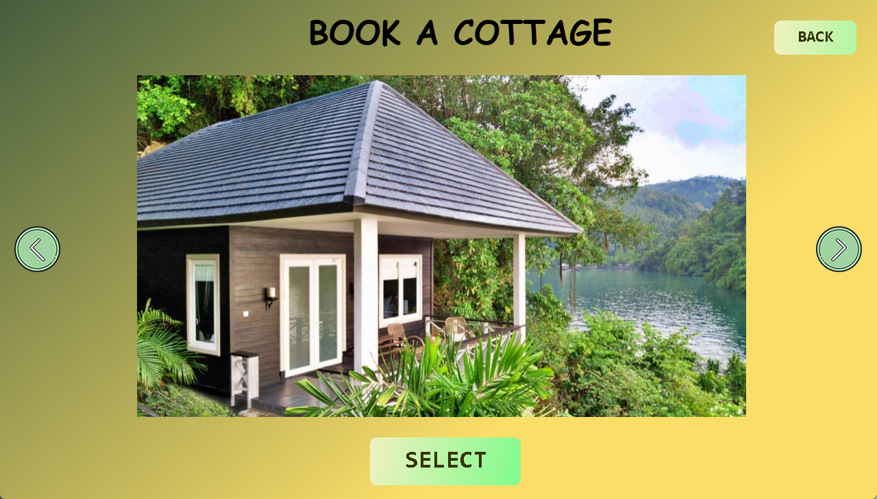

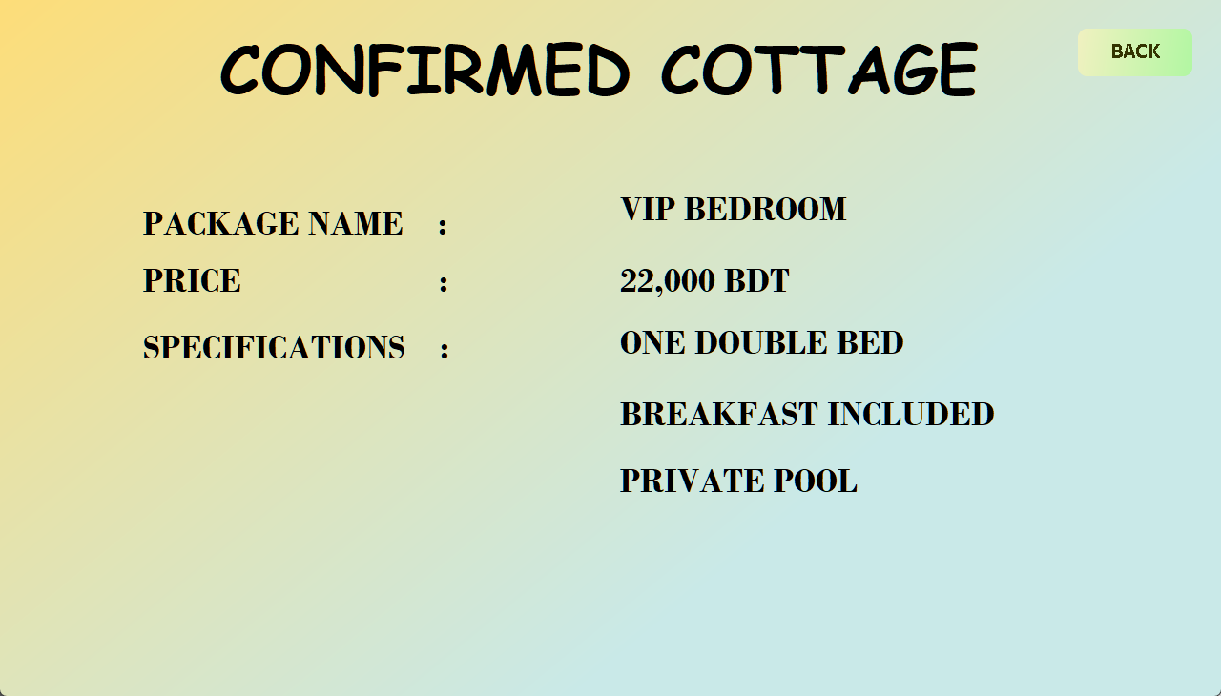

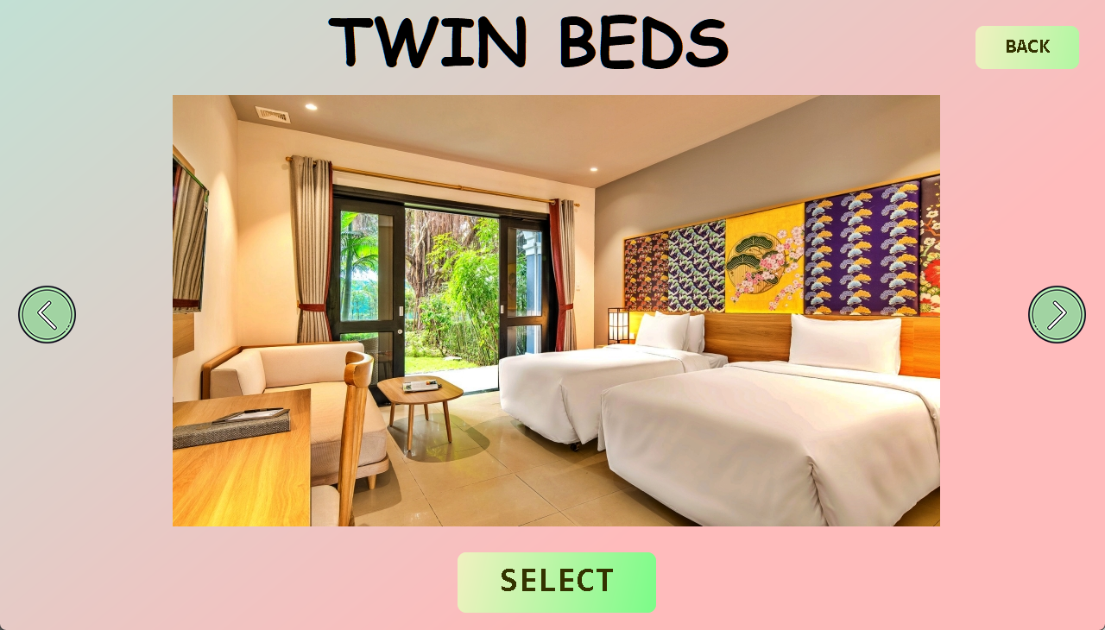

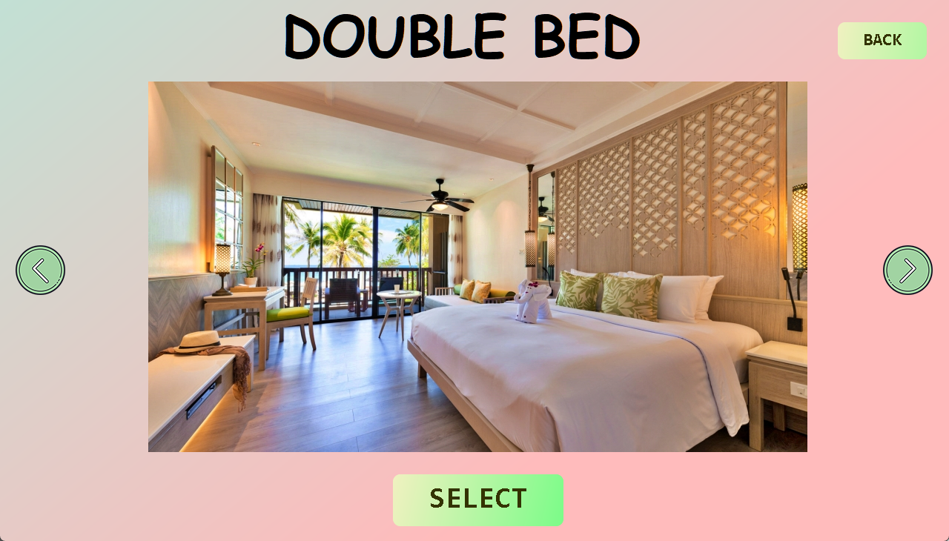

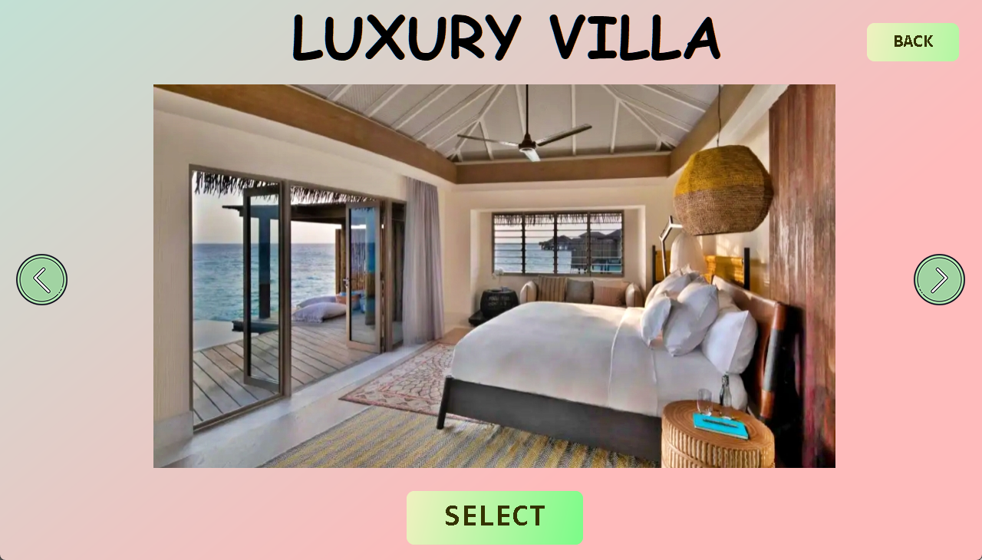

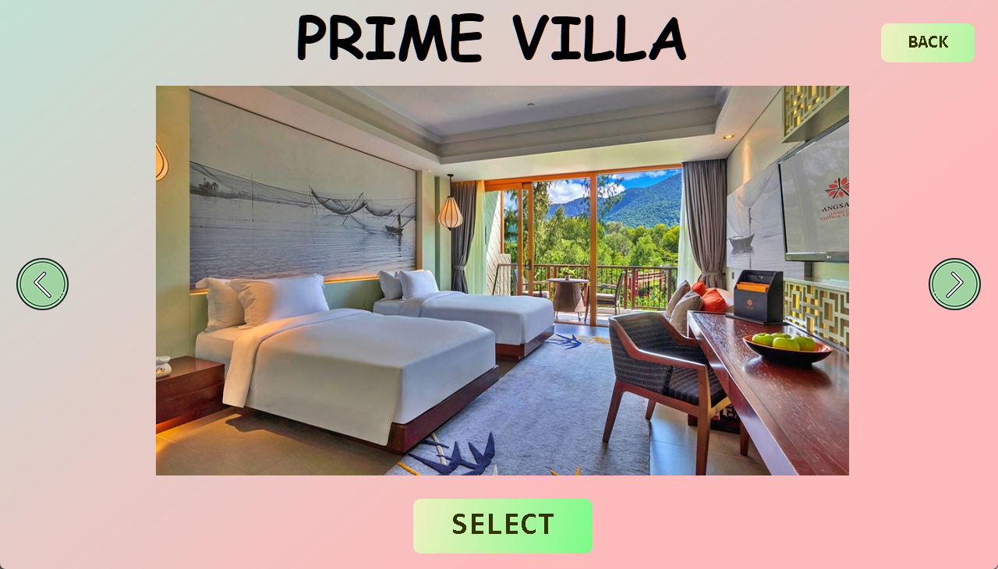

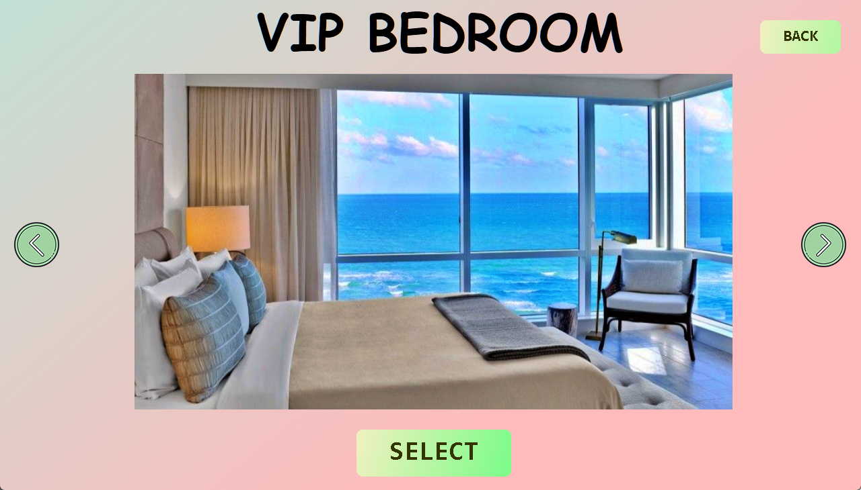

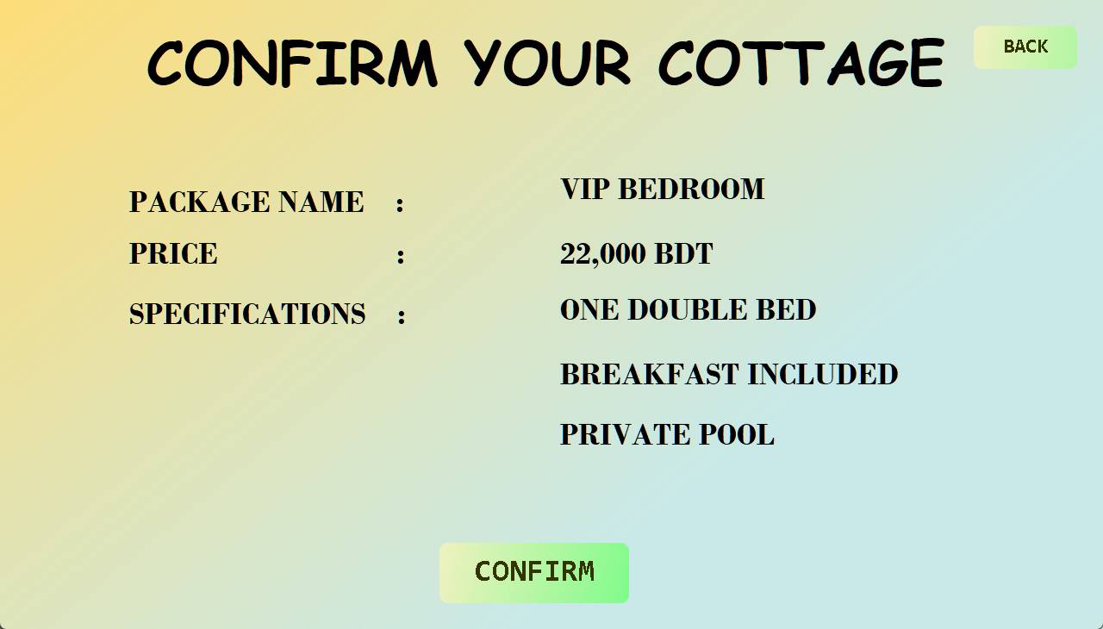

**• Book Venue:**

This feature allows a customer to book the whole/part of the resort for a function. They can choose the facilities they want to use that resort has to offer.

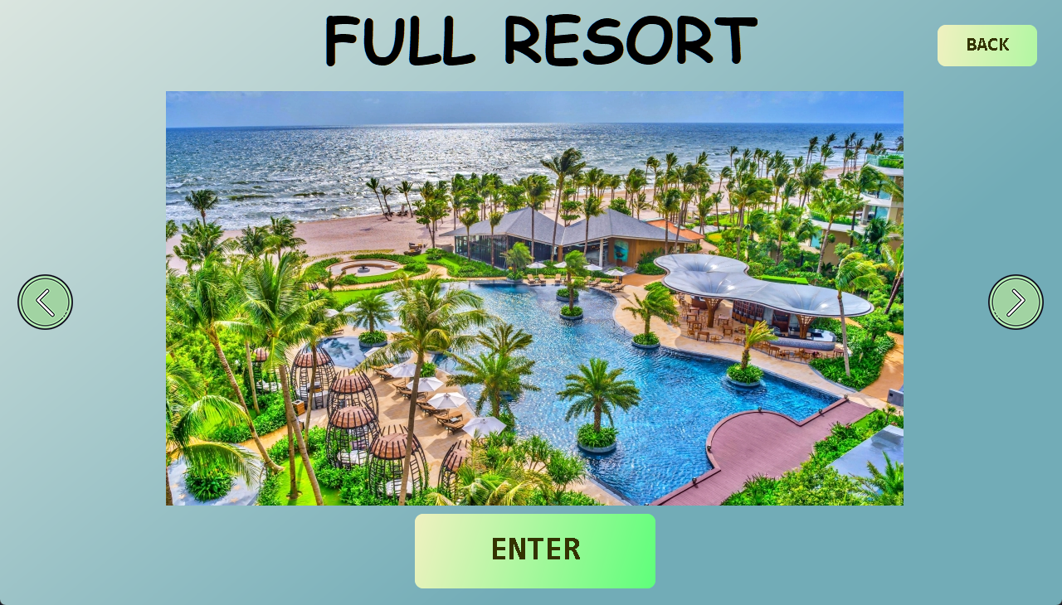

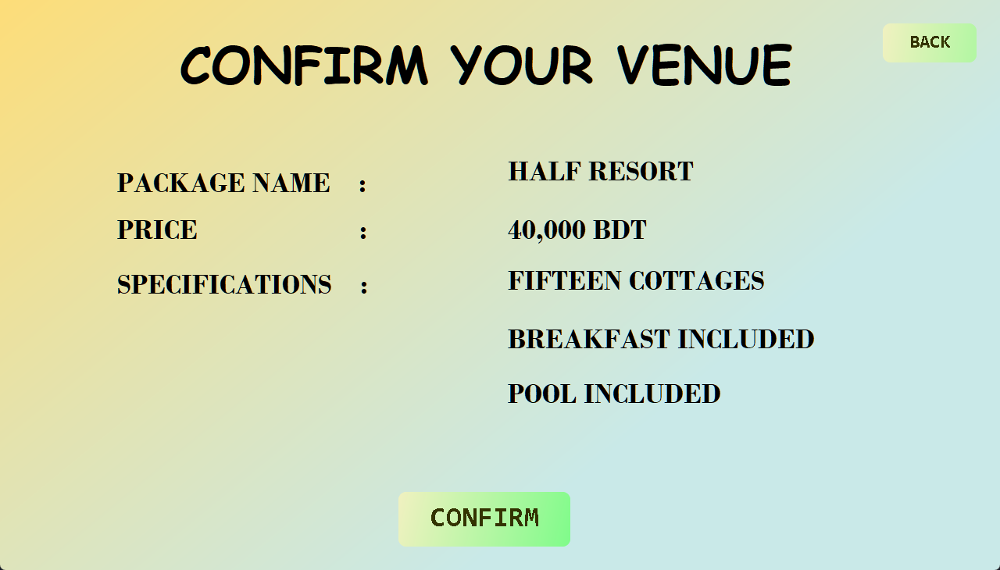

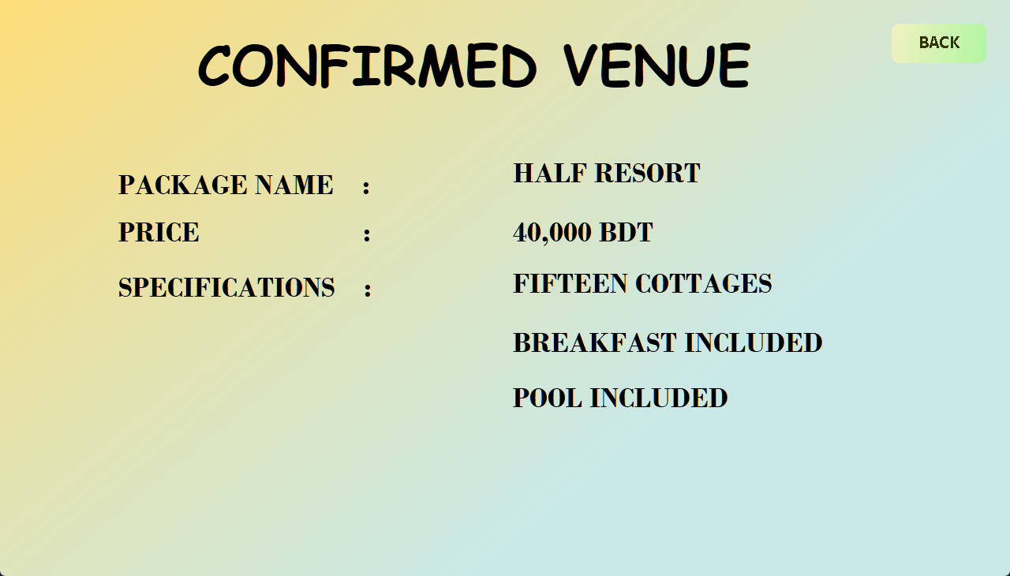

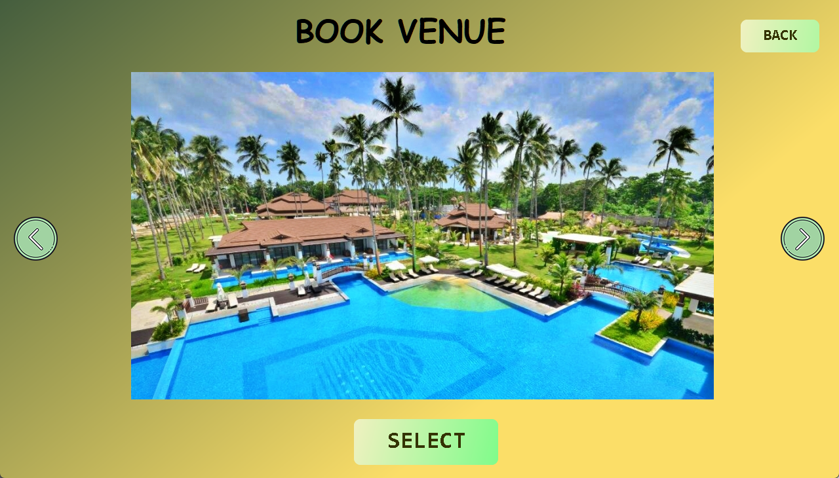

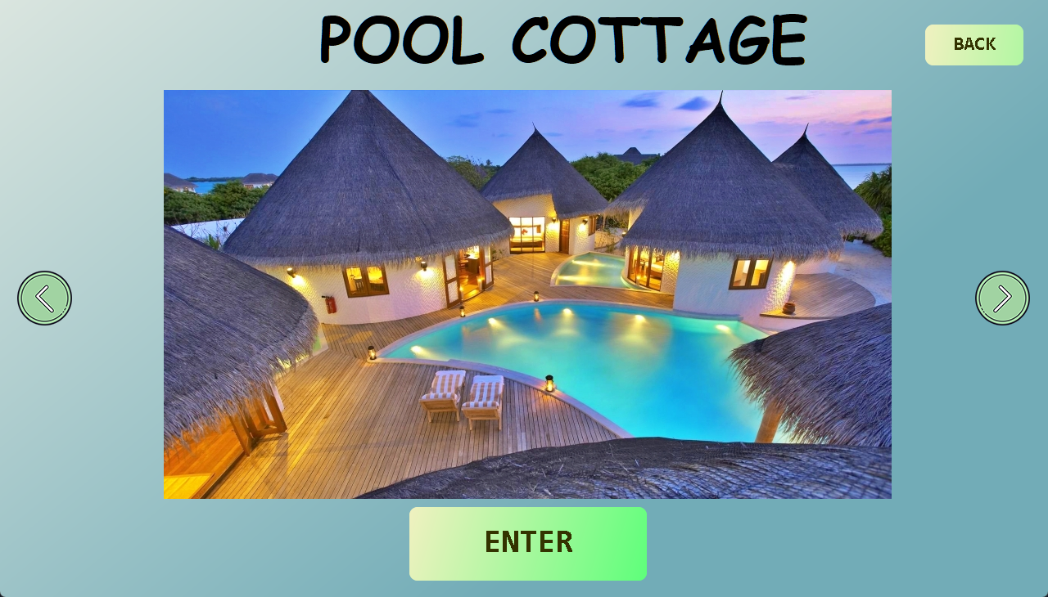

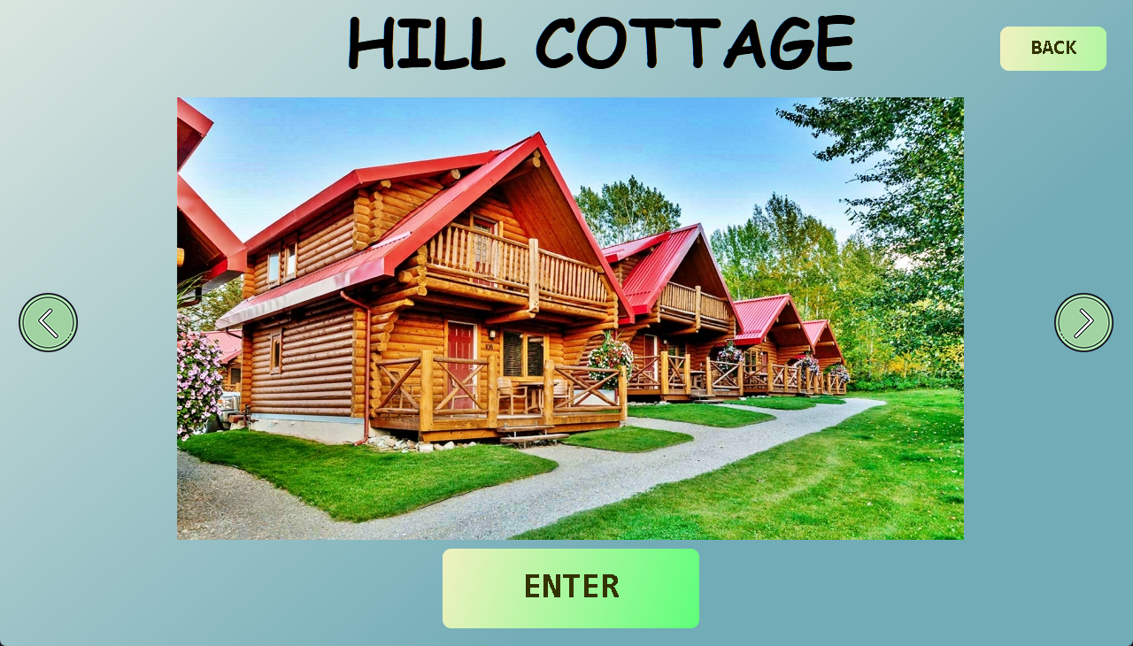

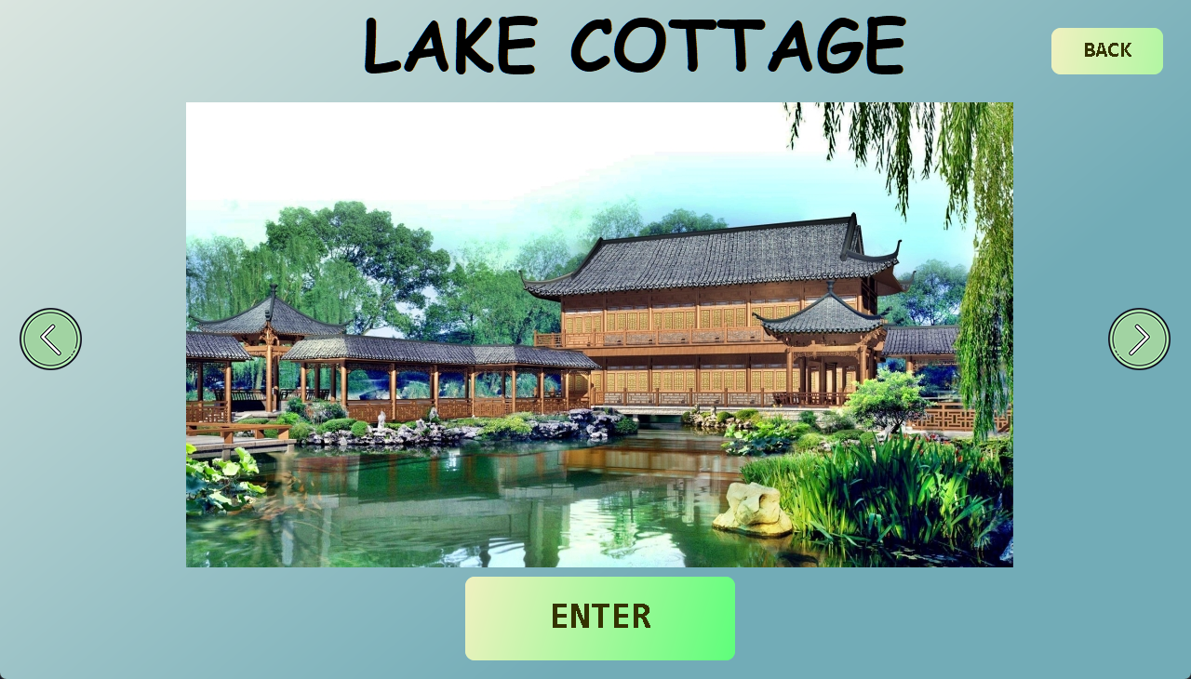

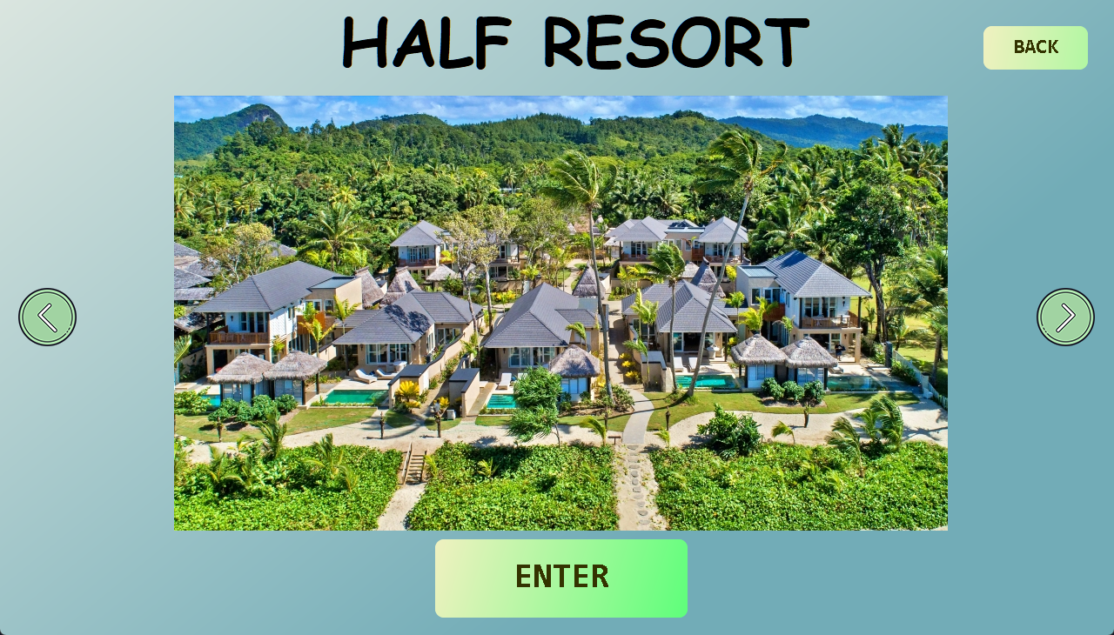

**• Book Tour:**

Our resort also provides transport and tour guides. This feature allows customers to book transport and escort if they want to travel to any destination.

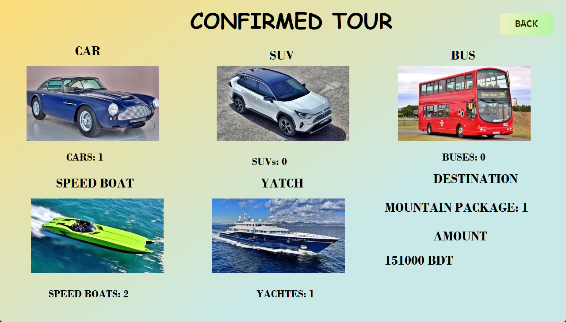



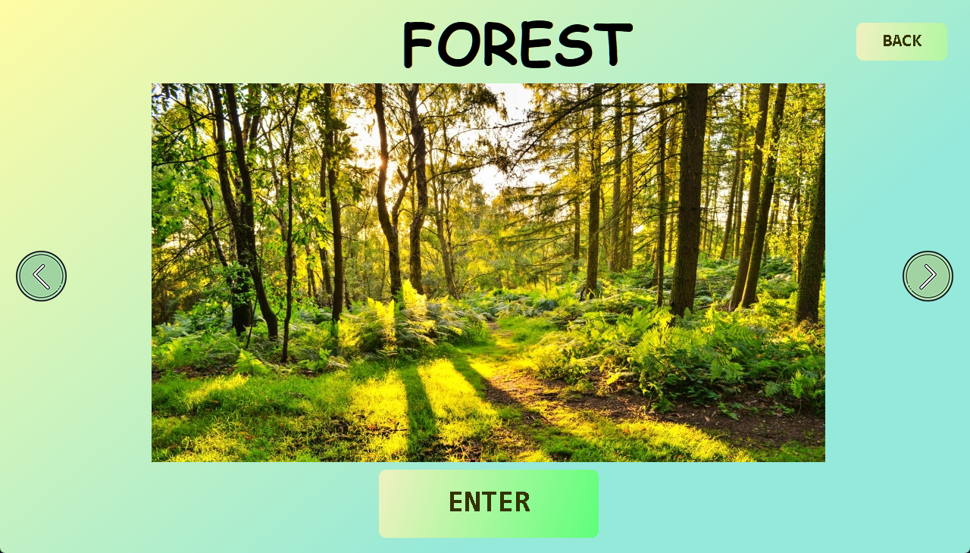

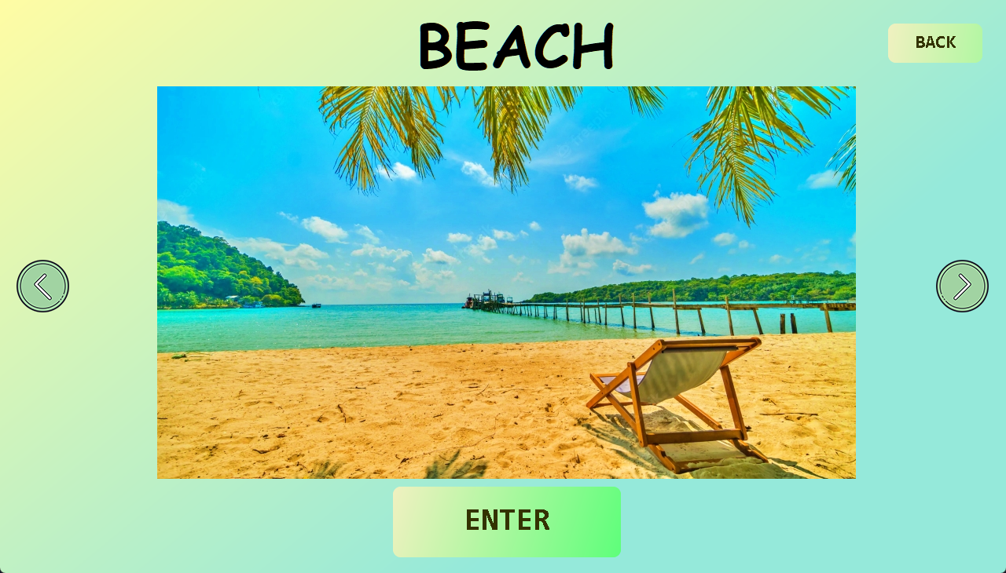

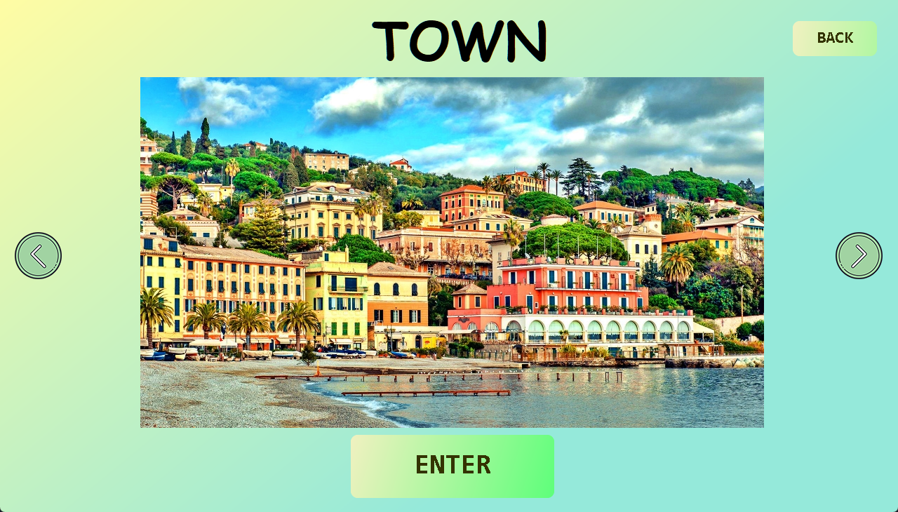

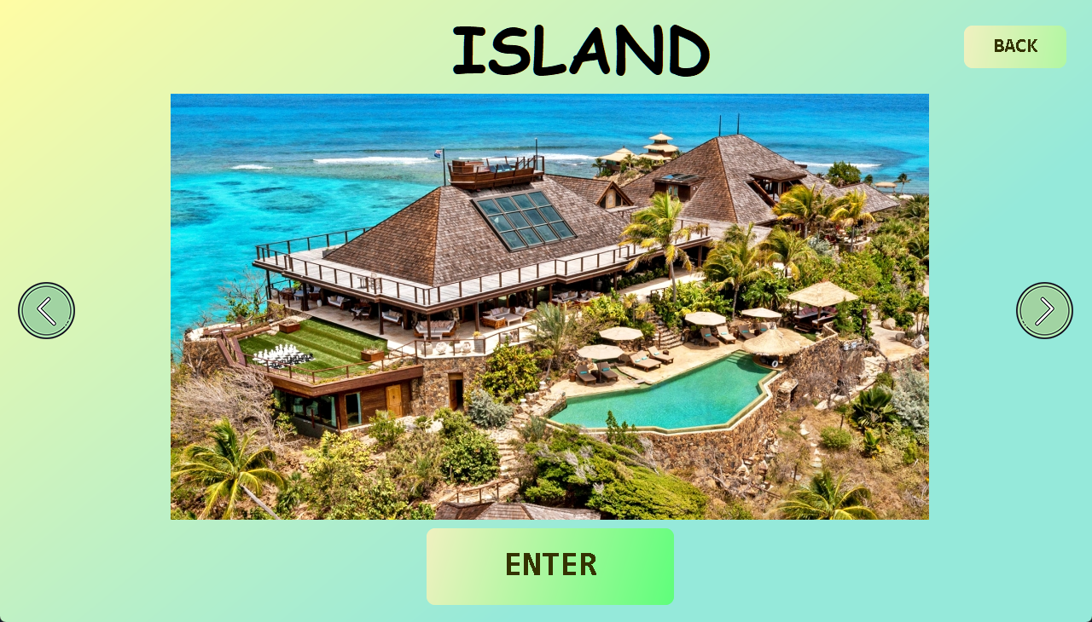

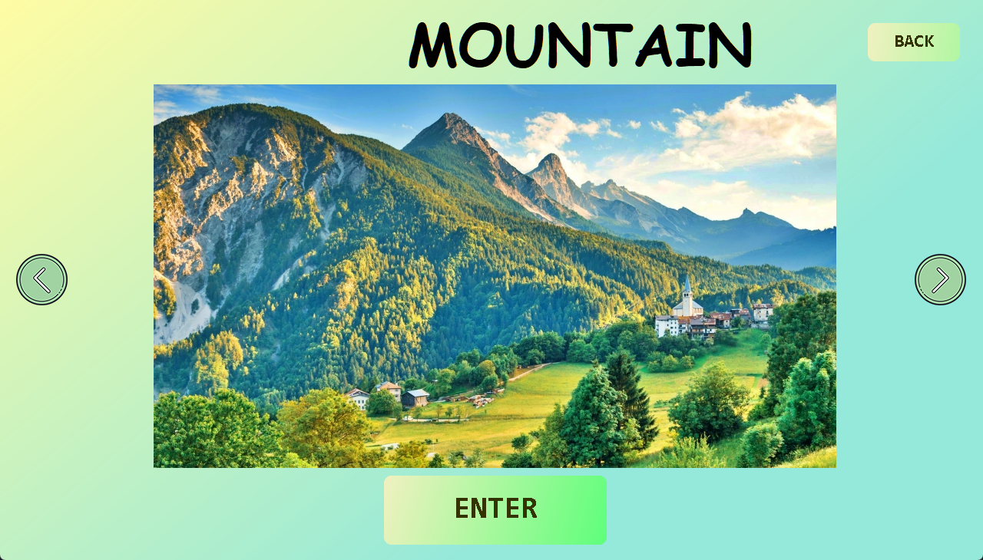

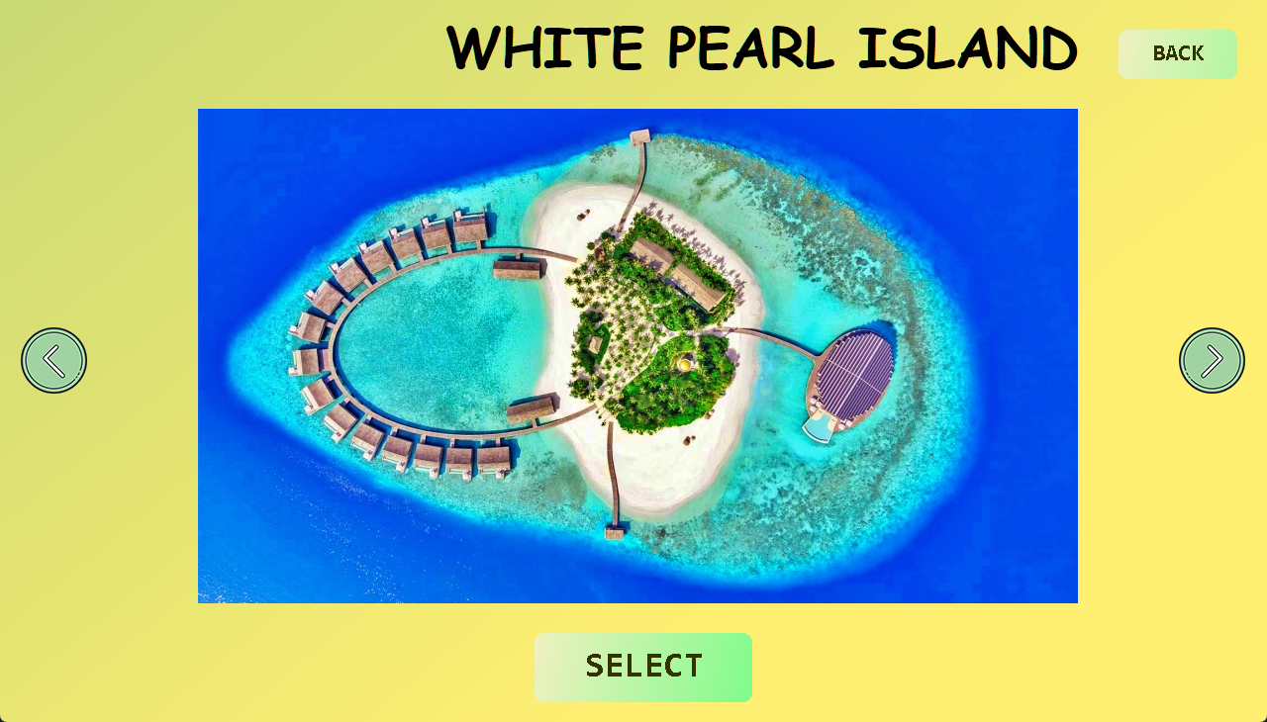

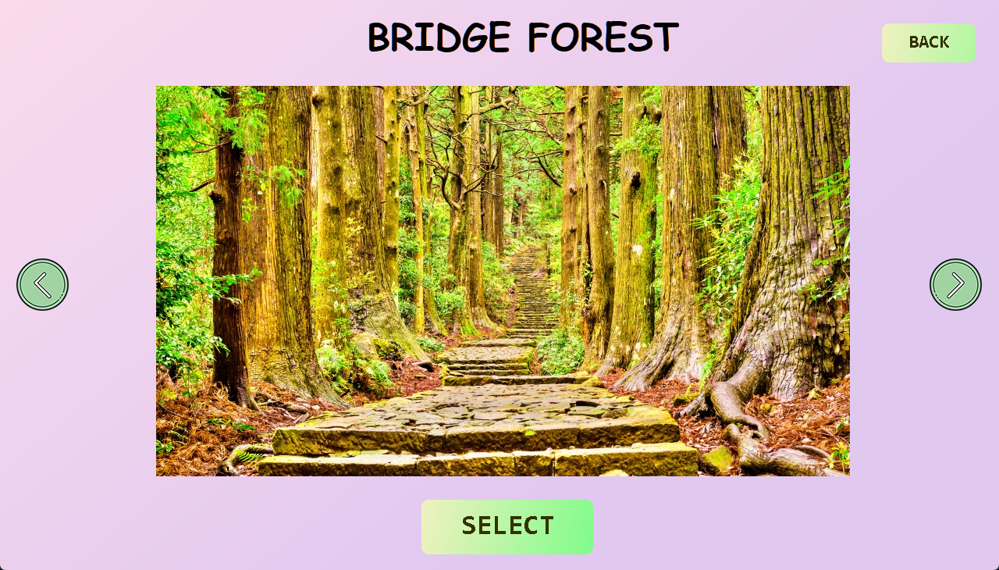

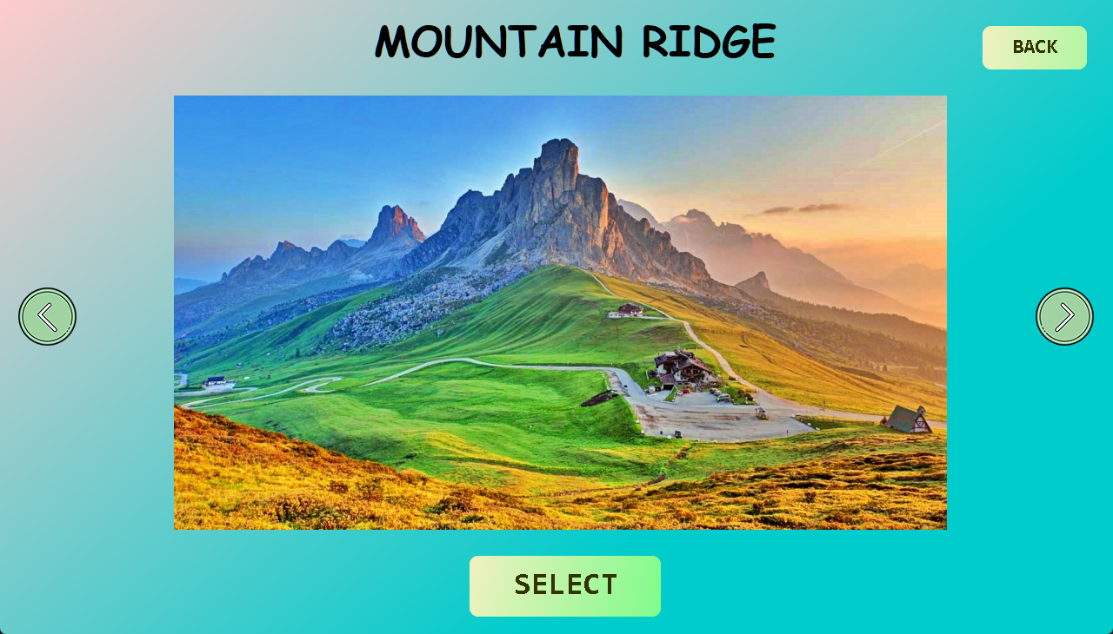

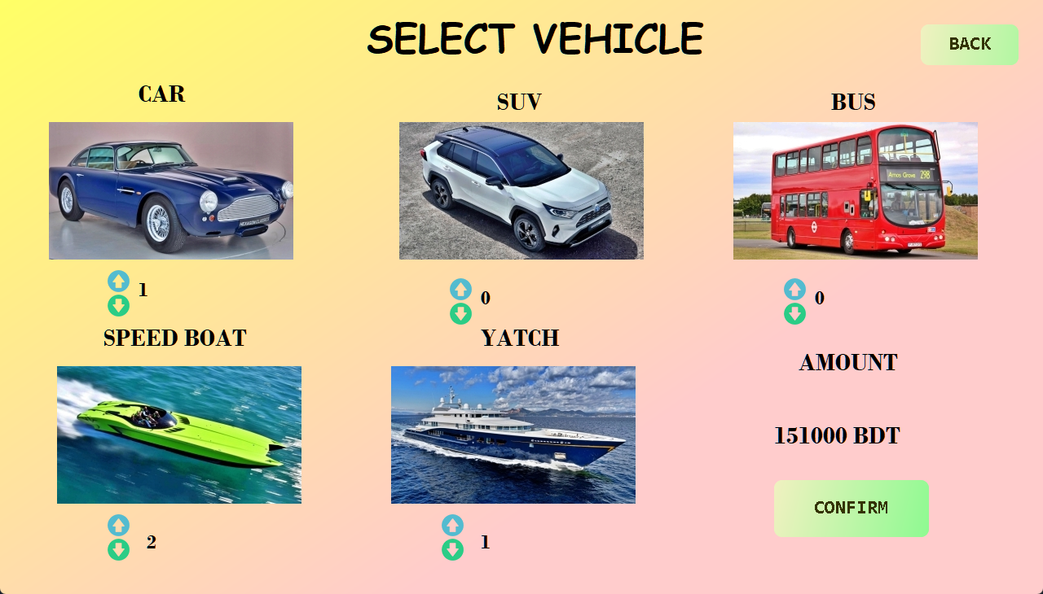

**• Get Gym Pass:**

This feature allows customers to get a gym pass for a specific time. If someone wants to work out at the resort gym, they have to request a gym pass. Then they will have a time slot reserved in the gym for them. 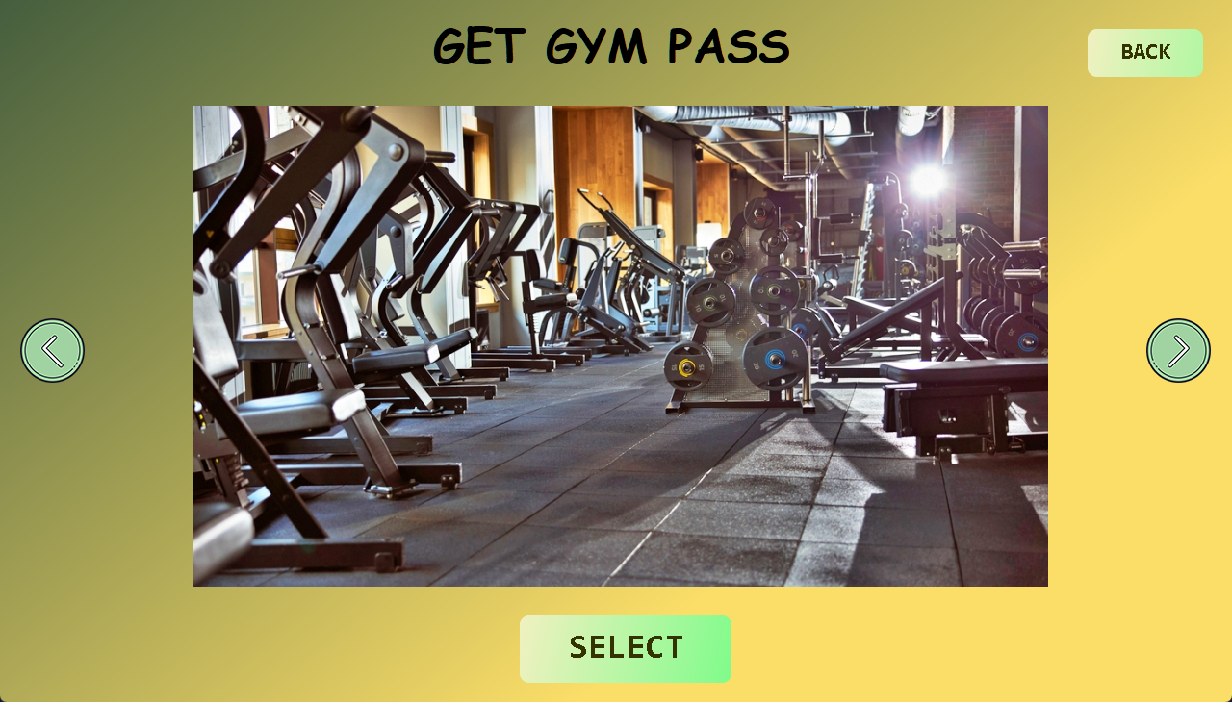

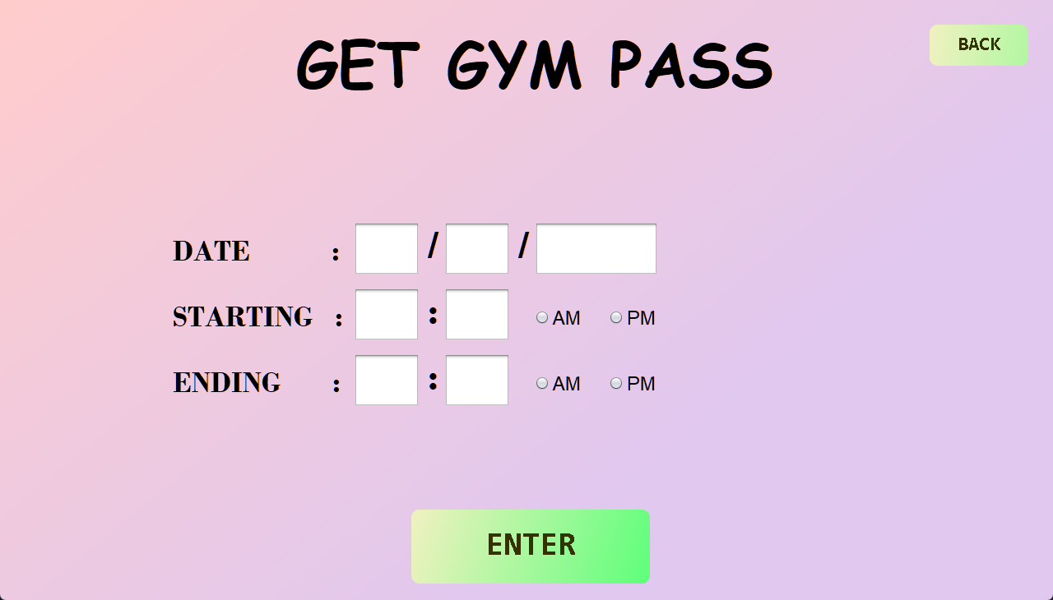

**• Withdraw Money:**

This feature allows customers to withdraw money from their bank accounts. They can log on to their account for withdrawing money and collect it from the resort booth. 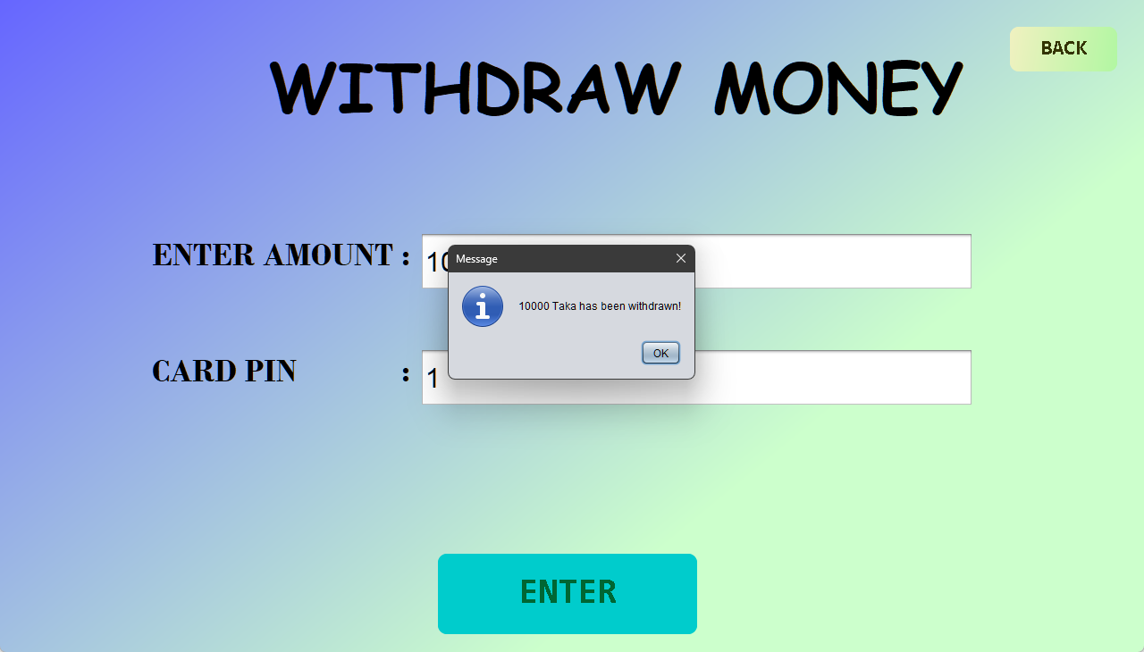

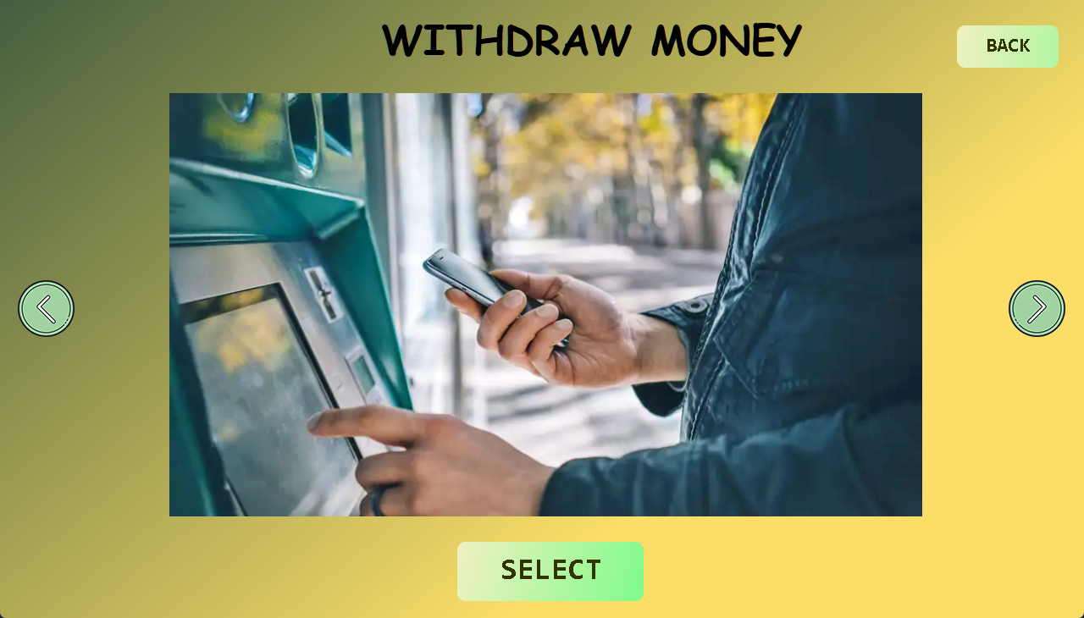

**• Request Health Support:**

This feature allows customers to request medical assistance in case of an emergency. A duty doctor will check up on the customer in need. The local hospital will be alerted if necessary.

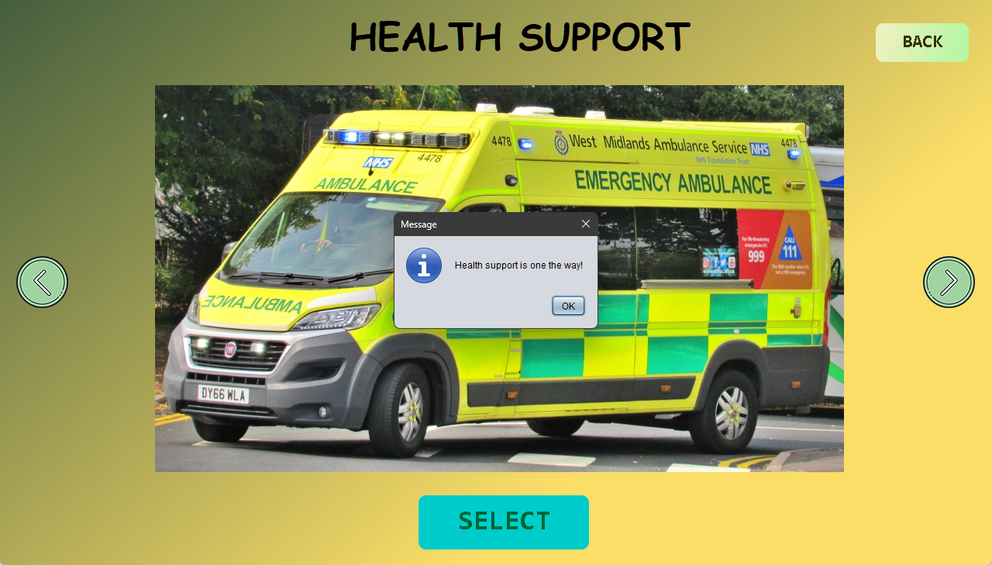

**• Rating Resort:**

This feature allows the customers to give our resort a rating based on their experience. The ratings will be public so that new customers can see their reviews. Administrative personnel will check the reviews daily to improve resort facilities.

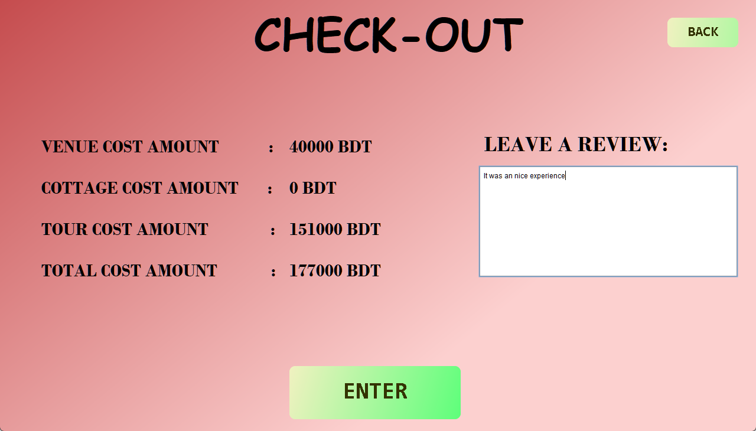

**Obstacles while working on the project:**

• Faced difficulties while choosing the GUI between Java swing and JavaFX

• Faced difficulties while working with MSQL because it took some time to get used to it

• Faced difficulties to re-design the whole project when the course teacher did not approve the first design

• Faced difficulties to generates new ideas as it is not similar to other management systems

**Differences between proposal and project:**

We dropped two features (Order Food & Grocery and Issue Book) according to our course teacher's opinion as it does not go with our project.

**Software and tools used:**

**• Java Swing**

**• NetBeans 8.2**

**• MySQL Work Bench**

**• VS Code**

**• Adobe Photo Shop**

**• Adobe Premiere Pro**

**• Git**

**• GitHub**

**Conclusion:**

As technologies and management are so important in our day-to-day life, it is essential to make a combined application to help humans. Our goal in making this project is to help an admin and customers of a resort to access the pieces of information, use the facilities and maintain strict security. It will also save the time of both admin and customer.

The admin can also get updates from the customers and knowledge about improvements.